Solution
https://drive.google.com/drive/folders/1o27FE0aeXMmXMOD9lV4bnLaLSy0QR1BF

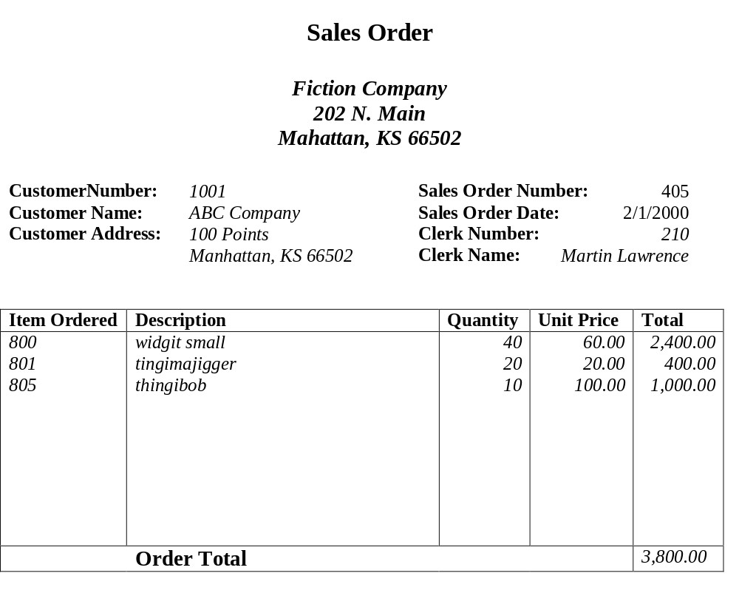
Example1:

Primary Key: Sales Order Number,

Example2:
